Learned how to add text padding:

<https://phaser.io/examples/v3/view/game-objects/text/text-padding>

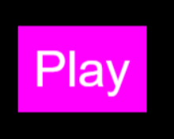

Rounded filled rectangles:

<https://phaser.io/examples/v3/view/game-objects/graphics/fill-rounded-rectangle>

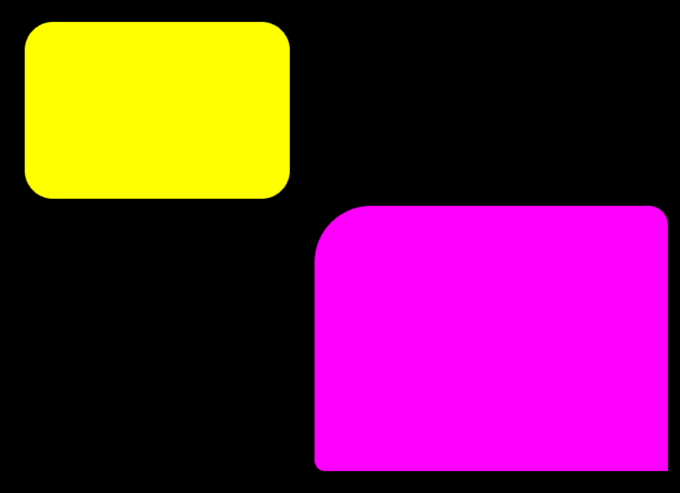

Stroke Rounded Rectangle:

<https://phaser.io/examples/v3/view/game-objects/graphics/stroke-rounded-rectangle>

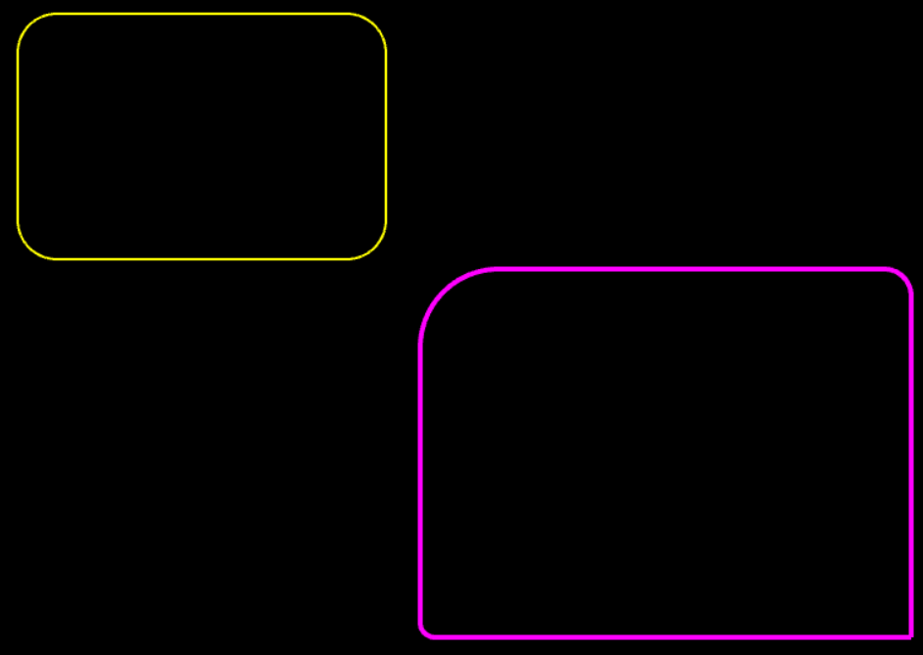

Rectangles + moving:

<https://phaser.io/examples/v3/view/game-objects/shapes/rectangle>

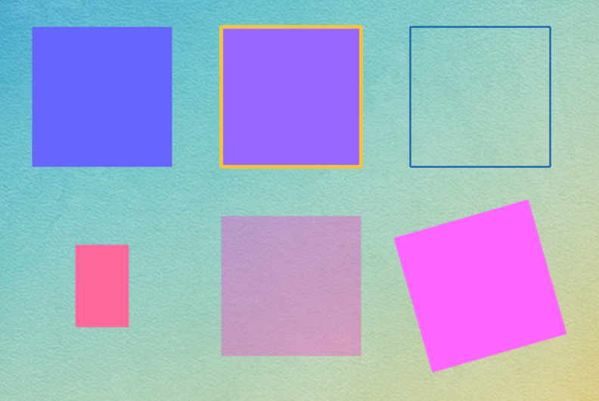

Check button released:

<https://phaser.io/examples/v3/view/input/mouse/check-button-released>



Game title

<https://phaser.io/examples/v3/view/game-config/game-title>

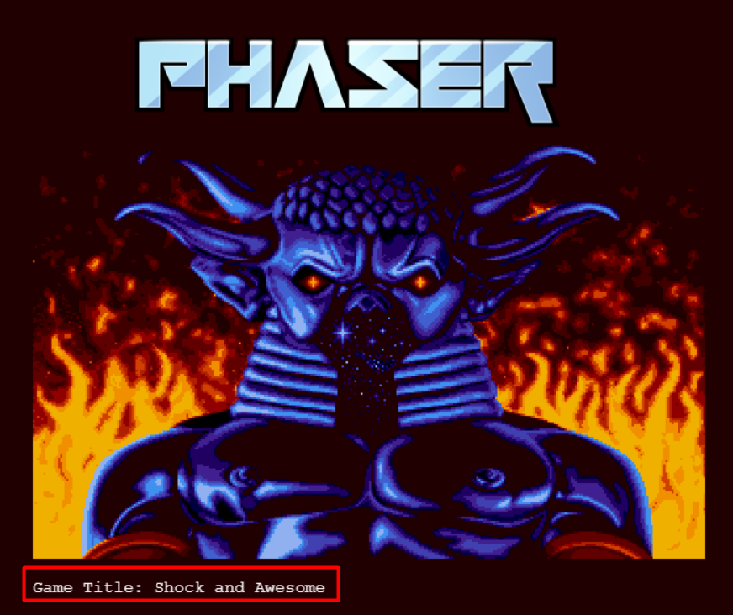

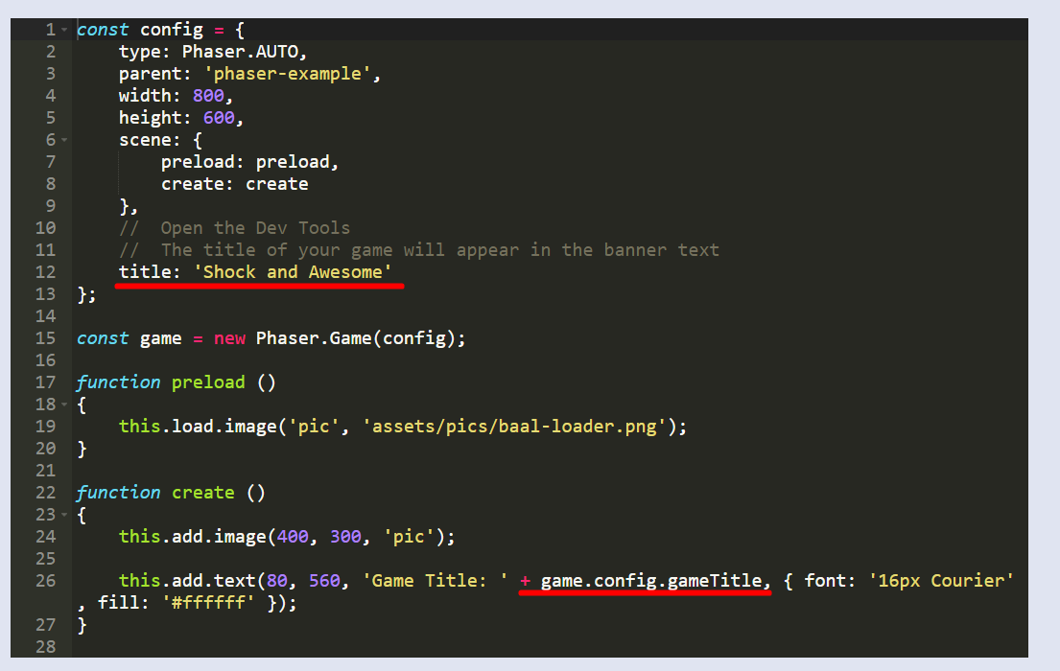

Center text on screen: <https://www.stephengarside.co.uk/blog/phaser-3-center-text-in-middle-of-screen/>

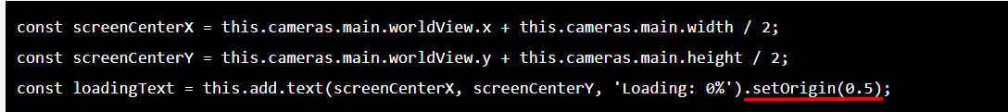

Iso Birdie

<https://phaser.io/examples/v3/view/game-objects/shapes/iso-birdie>

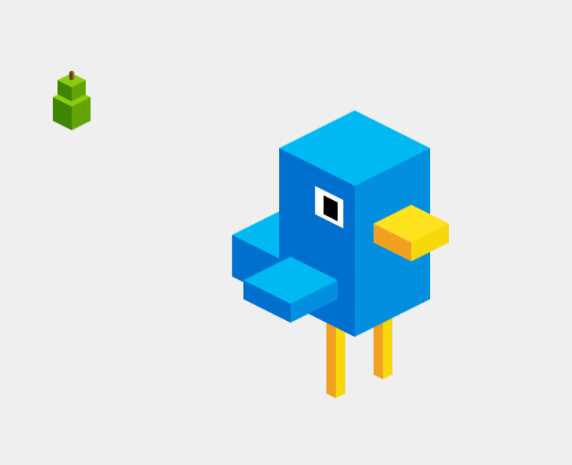

Line to ellipse

<https://phaser.io/examples/v3/view/paths/line-to-ellipse>

